White Paper : Executive Coaching

Introduction:

Today’s executive lives in a time of unprecedented change and complexity. The pressure to perform is intense. There are no escape hatches. Be it focussing on the bottomline or creating the next breakthrough product, building intellectual capital or leading an acquisition, the challenges are many and varied. Faced with ever increasing demands, an executive needs help in navigating through the uncertainty and ambiguity. And here’s where an executive coach steps in. The role of the coach is to enable the executive in defining, finding a pathway and reaching the goals that he desires - be it a business outcome or a behavioral change.

What is Executive Coaching ?

Executive coaching is a confidential one on one interactive process which is focussed toward helping the coachee develop his leadership and achieve the desired goals and outcomes. The coaching agenda is tailored for the person and is usually time defined and action oriented. In most cases, it also uses various tools to provide objective feedback to the coachee. The ultimate goal of coaching is to enable the coachee to perform to his highest potential.

Coaching draws from the worlds of consulting and therapy but is distinct from them in terms of its objectives, approach and outcomes. The idea is to build on the strengths of the executive and look at ways to navigate the gaps that might be emerging.

Why are Executive coaches engaged?

It is not without reason that some of the worlds top most executives, from Steve Jobs and Bill Gates to Larry Bossidy and Jeff Immelt actively advocate having an executive coach to help them learn more deeply and action their intent in a productive and efficient way

How does Executive Coaching help you?

While there may be many benefits that arise out of an executive coaching process, the essential elements of the 4-D coaching process are as defined below.

Discover: This is often the first step where the coachee and the coach together explore various elements including the coachees current leadership challenges, his leadership competencies through a variety of ways including psychometric assessments and 360 degree feedback. The outcome of the discovery process is the clarity and understanding of the ‘as-is’ situation. These are deep, reflective and challenging conversations that shine a light on the blind spots, clarify outdated values and often test ones assumptions about reality. This also helps define the coachee ’s goals in terms of outcomes, measures and success factors. This may include both behavioral shifts and business goals as required

Design: Here the coach helps you formulate the set of actions that would lead to achieving the goals you have. This phase is crafted around the individuals strengths and is a test and learn phase given that the coachee is experimenting with new and different behaviors and actions. An important part of this phase in also to ensure a structure for execution and creating accountability for the process

Develop: Here the leader engages in developing the leadership skills he needs to deliver his future. Be it shifting toward being more strategic or improving his ability to influence stakeholders, the executive engages in deep shifts of behaviors to enable his growth and development as an inspirational role model

Deliver - This is the closure of the process where in the coachee has been able to sustain the changed behaviors and taken the committed actions toward his growth

( May need to create a more visual chart which shows the above)

Who should you hire as a coach?

It is crucial to establish rapport and a trusting relationship with the coach early in the process. Success is dependent on a good chemistry between the coach and the coachee. Also important is the coach’s familiarity with coaching someone around similar areas.
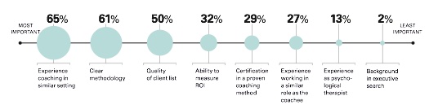
What are right attributes for a caochee?

Just as important as the coach is to the process, success requires that the coachee not only commit to the process but is also change ready and is willing to engage in the process of his own growth.
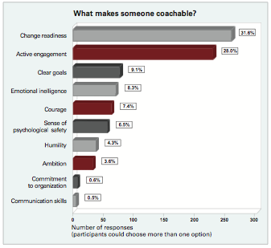

Summary

The real idea behind the executive coaching process is to unlock an individual’s potential and leverage his strengths toward performing at his best. For a coaching process to be successful, many parts have to come together - the coachee s commitment to change, a coach’s experience in enabling and inspiring the coachee and a clear process that builds structure and accountability for the plans and actions.

